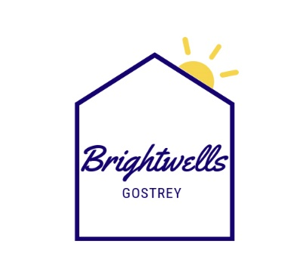

BRIGHTWELLS COMMUNITY MEAL SERVICE
Memorial Hall, Babbs Mead, Farnham, Surrey, GU9 7EE
T: 01252 727280
E: communitymeals@brightwellsgostrey.org

Welcome to our Community Meal Service.

Please find attached a copy of our 4-week rolling menu.

Our meals are freshly prepared in our kitchen with a choice of main meal of the day or vegetarian option. We endeavour to deliver the meal to the home between 11.45am and 1.30pm Monday - Friday. We also offer an afternoon tea service; a sandwich (fillings change daily) and cake delivered at the same time as lunch. In addition to this we can provide frozen meal/s for the evenings and weekends.

Our daily meals are delivered hot, ready to be eaten straightaway - they should not be left to cool and reheated later. We cannot leave a meal unless there is someone there to receive it. This is all part of our safe and well check. If there is no answer when we deliver the meal, we will contact the designated next of kin/neighbour/friend in case of illness or in need of help.

If you wish to cancel a meal for any reason, please telephone the Community Meals office on 01252 727280 before 9:30 am on the day. The office is open Monday to Friday 9:00 am to 1:00 pm.

Our prices are as follows:

Meal & Pudding - £8.00 per day
Afternoon Tea - £4.00 per day
Frozen Meal & Pudding - £8.00 per day

In terms of payment, we have a direct debit service in place, which can be set up by a next of kin/ relative.

All our volunteer delivery drivers have full access to PPE with a mask, gloves, visor, and hand sanitiser. It is no problem for them to either hand our meals over to you at the door or come in if you need and are happy for them to.

If you would like to go ahead, please complete the referral form, menus and return to enable us to set you up on our system.

BRIGHTWELLS COMMUNITY MEAL SERVICE
CLIENT INFORMATION FORM

Name
Address
Postcode
Date Of Birth
Telephone Number |  |  |  |  |  |  | Mobile:
Type of Home | Bungalow |  | House |  |  |  |  |  | Flat
Keysafe Number |  |  |  |  | Does Client Live Alone:  YES / NO
Directions / Additional Access Info
Physical Impairments
Diabetic Allergies / Dietary Requirements
Lunchtime Meal Requirement (£8.00) | MON | TUES |  | WEDS |  |  |  | THURS |  | FRI
Frozen Evening Meal  (£8.00) | MON | TUES |  | WEDS |  |  |  | THURS |  | FRI
Weekend Frozen Meal  (£8.00) | SATURDAY |  |  |  |  | SUNDAY
Afternoon Tea Service  (£4.00) | MON | TUES |  | WEDS |  |  |  | THURS |  | FRI
Start Date
Any Other Client Information

NEXT OF KIN / EMERGENCY CONTACT INFORMATION
Name
Relationship to Client
Daytime Telephone Number
Mobile
Email
Name
Relationship to Client
Daytime Telephone Number
Mobile
Email

ACCOUNTS – DIRECT DEBIT MANDATE INFORMATION
Account Name
Account Number
Sort Code
Email Address for Confirmation of DD

TERMS & CONDITIONS

I agree for a deposit of £50 to be taken via direct debit from the nominated account above. The deposit will be refunded on the termination of this contract, subject to the settlement of any outstanding items.

I agree for payment of the meals received to be collected via monthly variable Direct Debit.

Failure to collect / late payments after the period of one month will result in the meal service being stopped, with no further meals provided until the outstanding amount is paid.

I agree to pay a sum of £8.00 per meal/ pudding, £4.00 per afternoon tea, £8.00 per frozen meal/ pudding item as delivered at the frequency indicated above. Brightwells Gostrey reserves the right to review and adjusting prices accordingly.

All amounts are stated are inclusive of VAT and any other applicable taxes unless expressly stated otherwise.

……………………………………………………………………………………………
SIGNED – CLIENT / NEXT OF KIN

……………………………………………………………………………………………
PRINT NAME

……………………………………………………………………………………………
DATE

